BSc (Hons) in Information Technology Information Technology


Year 4
Visual Analytics and User Experience Design
IT4031
Assignment 1

Name | IT Number
Bandara S N M T | IT22895028
Siriwardhana N S | IT22348166
Nilmani G A K | IT22003614
Thisaravi R D H | IT22541598

Table of Contents
Introduction 4
Step 1 – Empathize: User Research 5
1.1 Stakeholder Identification 5
1.2 User Research Methodology 5
1.3 Personas 7
1.4 Empathy Maps 11
Step 2: Define – Problem Framing and Insight Synthesis 13
2.1 Research Insight Analysis 13
2.2 Problem Statements 14
2.3 User Stories 14
2.4 How Might We (HMW) Questions 14
2.5 User Journey Map 15
2.6 Task Flow Diagram 16
Step 3: Ideate – Dashboard Concept and Information Architecture 17
3.1 Dashboard Concept 17
3.2 Information Architecture 17
3.3 Navigation Structure 18
3.4 Low-Fidelity Wireframes 18
3.5 Visualization Selection 20
3.6 Interaction Mechanisms 20
Step 4: Prototype – High-Fidelity Interactive Design 21
4.1 High-Fidelity Dashboard Design 21
4.2 Responsive Design 21
4.3 Mobile View 22
4.4 Desktop View 23
4.4 Interactive Features 23
4.4 Interactive Features 23
➢ Visual Hierarchy Important information such as current power and predicted power is placed at the top of the dashboard. 23
4.5 Prototype Screenshots 24
4.6 Prototype Link 25
Step 5: Test – Usability Evaluation 26
5.1 Stakeholders Involved in Usability Testing 26
5.2 Task-Based Usability Testing 26
5.3 Usability Metrics 27
5.4 Heuristic Evaluation 28
5.5 Key Findings 28
5.6 Usability Issues Identified 28
5.7 Recommendations for Improvement 29
Step 6: Iterate – Design Refinement 30
6.1 Identified Usability Issues 30
6.2 Design Improvements 30
6.3 Before–After Design Comparison 31
6.4 Design Iteration Summary 31
Step 7: Design Handoff Report 32
7.1 Final Dashboard Structure 32
7.2 Screen Specifications 32
7.3 Interaction Behaviors 33
7.4 Visualization Guidelines 34
7.5 Responsive Design Guidelines 34
7.6 Accessibility Considerations 35
7.7 Implementation Considerations 35

Introduction
Renewable energy systems, such as photovoltaic solar installations, require effective monitoring and analysis to ensure optimal performance. Modern solar systems generate large volumes of sensor data, including power output, voltage, current, temperature, and environmental conditions. Without the right visualization tools, it can be difficult for users to interpret this data and make timely operational decisions.
This project focuses on the design and evaluation of a responsive web-based visual analytics dashboard for monitoring a solar tracking system. The dashboard integrates real-time IoT sensor data and analytical visualizations to help users monitor system performance, detect anomalies, and assess power generation trends.
The system collects sensor data from a solar tracking system that continuously adjusts the solar panel's orientation using light sensors and a servo motor. Additional sensors measure electrical power output and environmental conditions, such as temperature and sunlight intensity. These data streams are processed and displayed through an interactive dashboard that allows users to observe the system's behavior in real time and analyze historical trends.
The main objective of this project is to design a user-centered dashboard using the Design Thinking methodology, which includes the stages of empathy, definition, ideation, prototyping, testing, iteration, and design delivery. Following this process, the project aims to create a dashboard that improves usability, facilitates data-driven decision-making, and presents complex solar energy data in a clear and intuitive way.

Step 1 – Empathize: User Research

Stakeholder Identification
A solar monitoring dashboard is used by multiple stakeholders who rely on solar system data to monitor performance, plan energy usage, and maintain system health. Identifying these stakeholders helps ensure that the dashboard design addresses the needs of all users.
Four main stakeholders were identified.
Stakeholder | Role | Decision Type | Dashboard Needs
Solar System Operator | Monitors system performance | Operational | Real-time monitoring
Energy Manager | Plans energy usage | Tactical | Forecasting and trend analysis
Maintenance Technician | Maintains system hardware | Technical | Alerts and diagnostics
Academic Evaluator | Evaluates system performance | Analytical | Data visualization and model evaluation

User Research Methodology
To understand user needs and expectations for a solar monitoring dashboard, a questionnaire-based survey was conducted using Google Forms. The survey was distributed to individuals with knowledge of renewable energy systems, engineering technologies, or data monitoring systems.
The purpose of the survey was to identify:
- important information required in a solar monitoring dashboard
- preferred visualization methods
- usefulness of prediction features
- expected dashboard usability performance
The survey collected 8 responses from participants with different technical backgrounds.
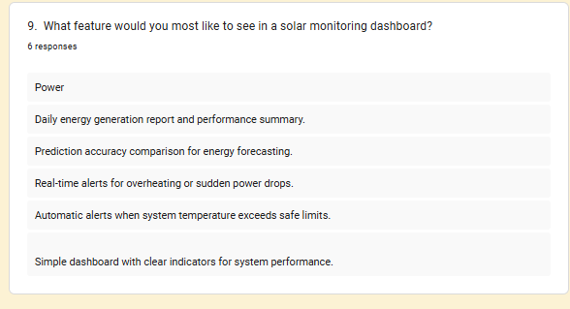
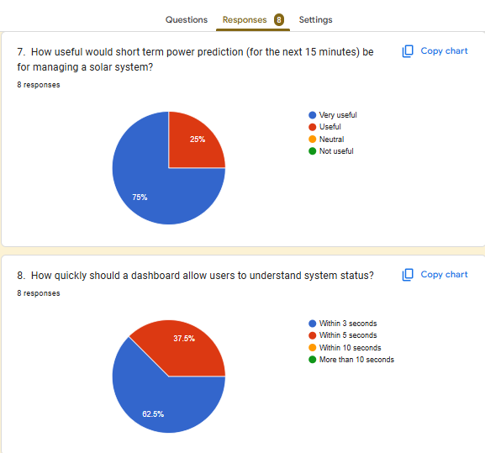
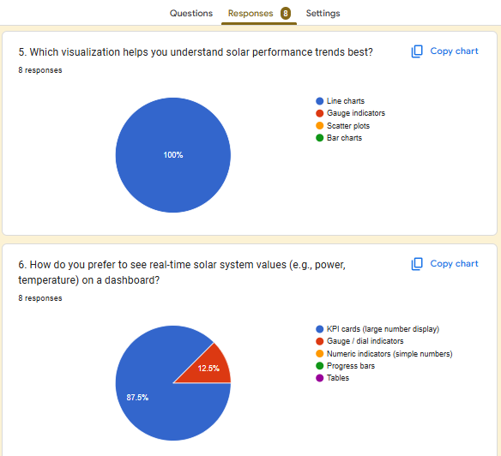
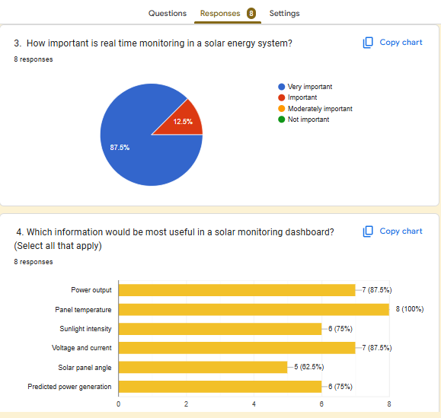
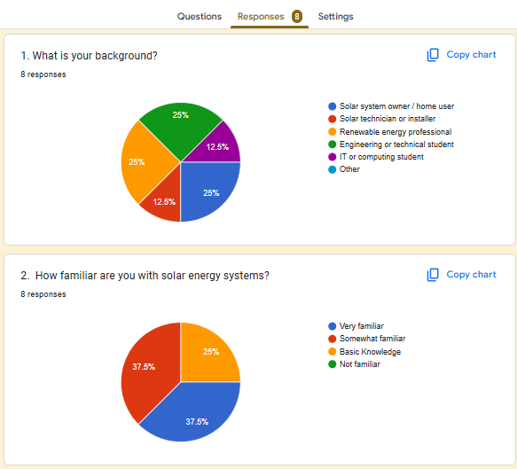

1.3 Personas
Persona 1 – Solar System Operator
Name | Ravi Perera
Age | 36
Occupation | Solar System Operator
Experience | 8 years working with solar energy systems
Background | Ravi manages a small solar power installation and monitors system performance daily. He relies on dashboards to observe power generation, sunlight intensity, and panel temperature.
Goals | - Monitor real-time solar power generation  - Detect performance drops quickly  - Ensure the solar panel tracking system is working correctly
Frustrations | - Dashboards that show too much data without clear focus  - Difficulty detecting system anomalies quickly
Needs | - Clear real-time monitoring indicators  - Alerts when system performance drops  - Easy visualization of power trends
Quote | I need to know immediately if my solar system is not performing properly.

Persona 2 – Energy Manager
Name | Nadeesha Fernando
Age | 41
Occupation | Energy Manager
Experience | 8 years working with solar energy systems
Background | Nadeesha manages energy usage for a facility using solar power. She analyzes energy production trends and plans how solar energy will be used throughout the day.
Goals | - Understand solar energy production trends  - Plan energy usage based on predicted power generation  - Improve overall energy efficiency
Frustrations | - Lack of forecasting tools in many monitoring systems  - Difficulty comparing predicted and actual energy generation
Needs | - Short-term solar power prediction  - Trend visualization of energy production  - Easy comparison between predicted and actual power
Quote | Forecasting helps me plan energy consumption more efficiently.

Persona 3 – Maintenance Technician
Name | Chaminda Silva
Age | 33
Occupation | Solar Maintenance Technician
Experience | 8 years working with solar energy systems
Background | Chaminda is responsible for maintaining solar panels, sensors, and monitoring equipment. He checks system alerts and investigates hardware issues.
Goals | - Detect hardware faults quickly  - Prevent system overheating or equipment damage  - Maintain stable system performance
Frustrations | - Late detection of sensor failures  - Lack of clear system alerts
Needs | - Temperature monitoring indicators  - Real-time alerts for abnormal conditions  - Easy access to system diagnostics
Quote | I need alerts immediately when something is wrong with the system.

Persona 4 – Academic Evaluator
Name | Dr. Kasun Wijeratne
Age | 45
Occupation | University Researcher / Evaluator
Experience | 8 years working with solar energy systems
Background | Dr. Kasun studies renewable energy systems and evaluates solar performance data. He analyzes historical trends and compares model predictions with real system output.
Goals | - Analyze solar system efficiency  - Evaluate prediction model accuracy  - Study environmental impacts on energy production
Frustrations | - Limited access to structured analytics data  - Poor visualization of prediction accuracy
Needs | - Analytical charts and data comparison tools  - Clear visualization of predicted vs actual power  - Historical trend analysis
Quote | Data visualization helps me understand system performance patterns.

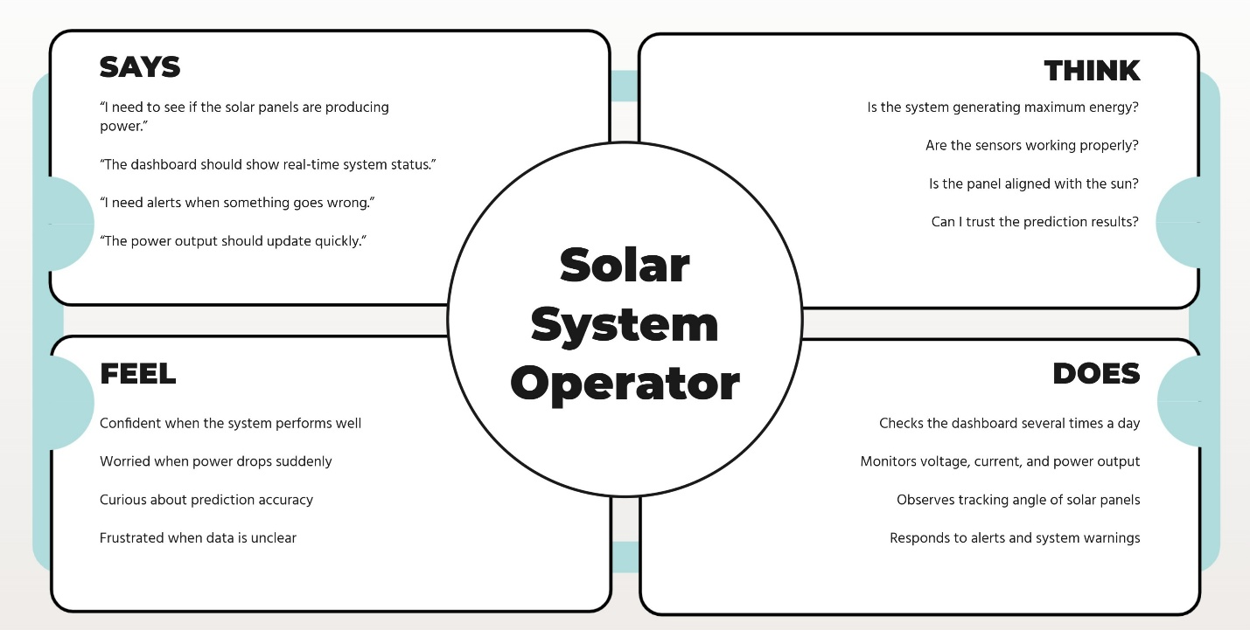
Empathy Maps
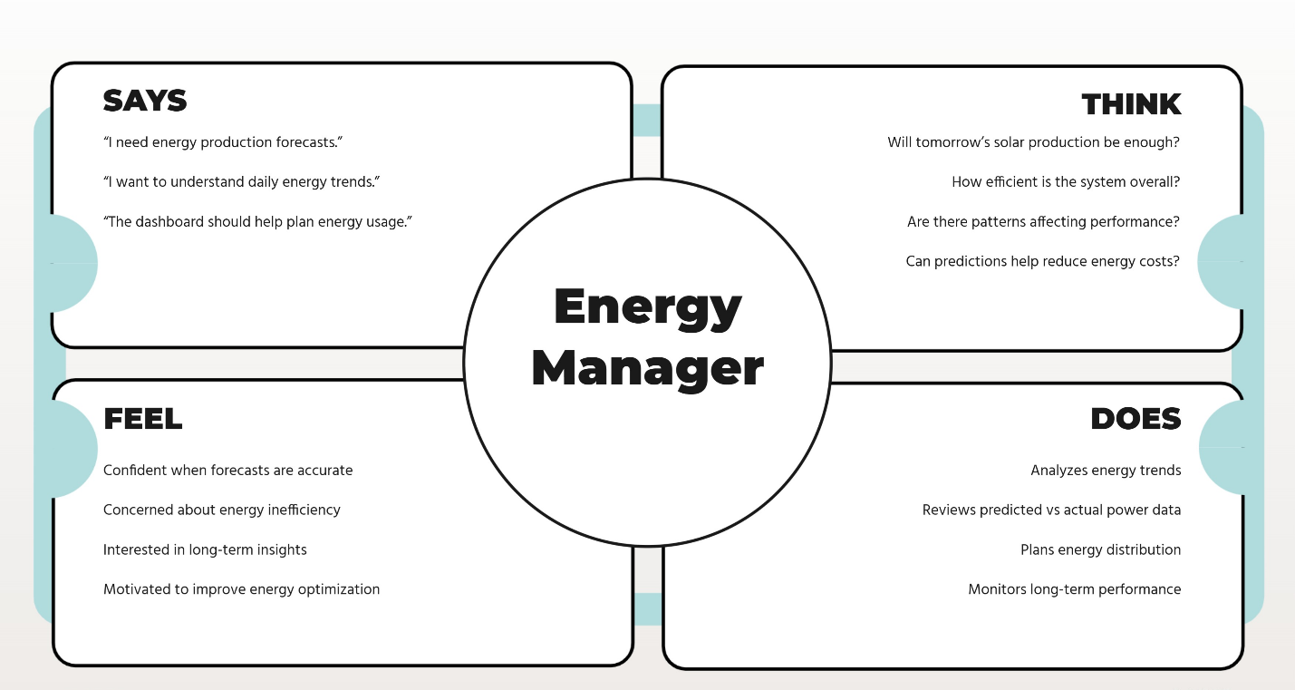

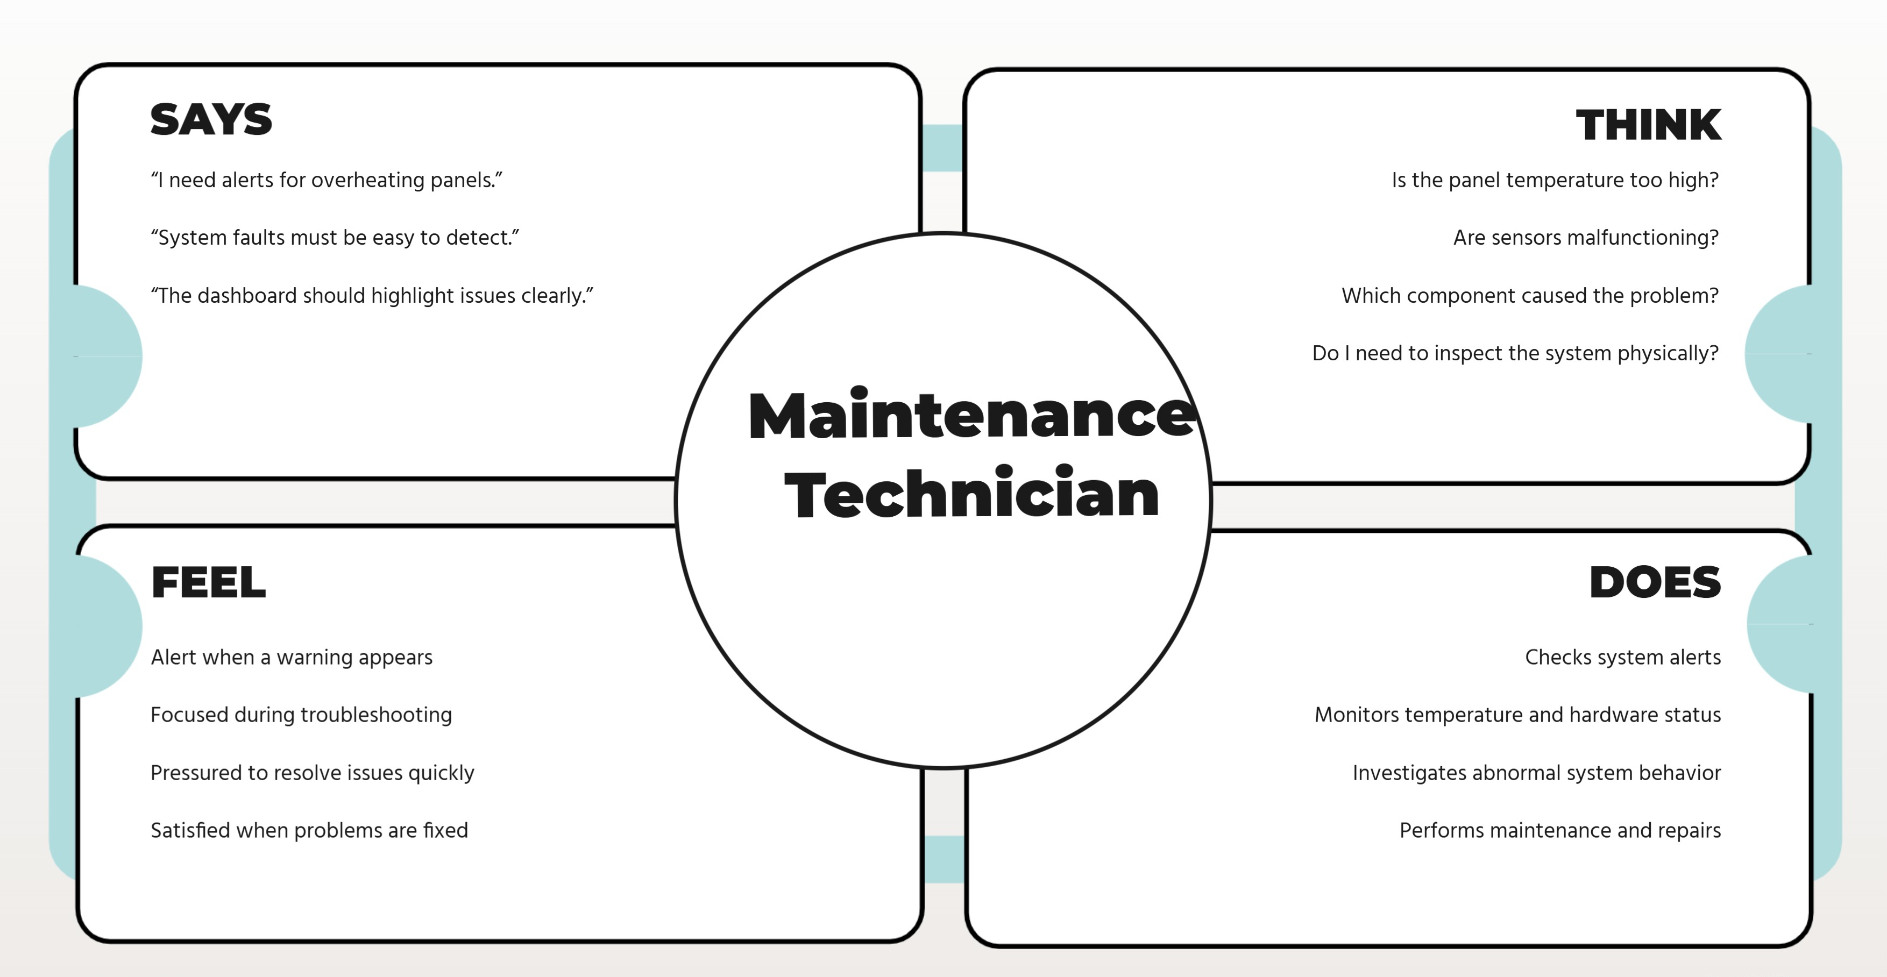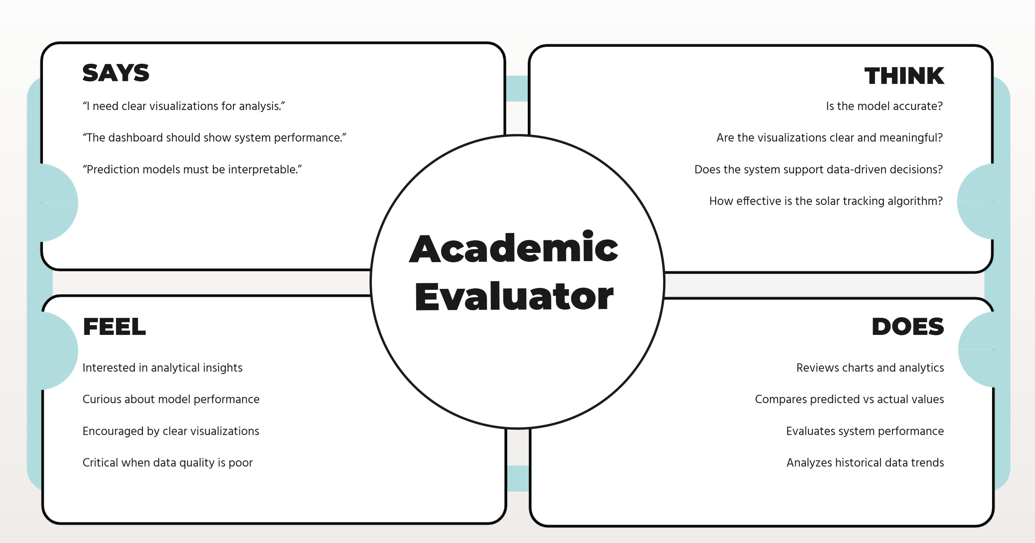

Step 2: Define – Problem Framing and Insight Synthesis

2.1 Research Insight Analysis

Based on the survey responses, interviews, and stakeholder analysis conducted in Step 1, several important insights were identified regarding the requirements of a solar monitoring dashboard. The analysis focused on understanding the information needs, operational challenges, and decision-making requirements of the different stakeholders.
User Needs
The research findings revealed several key user needs.
- Users need real-time visibility of solar power generation to monitor system performance.
- Users require clear visualization of environmental conditions, including light intensity and panel temperature.
- Users want short-term power prediction to support proactive energy management.
- Users expect alerts and notifications when abnormal system behavior occurs.
- Users require historical data visualization to analyze trends and system performance over time.
- Users need a simple and intuitive dashboard interface that allows quick interpretation of system status.
Pain Points
The research also identified several challenges faced by users when monitoring solar systems.
- Many existing systems provide only raw numerical data without meaningful visualization.
- Users find it difficult to detect anomalies such as overheating or sudden power drops quickly.
- Lack of prediction capability makes energy management reactive rather than proactive.
- Data is often displayed in separate systems, making analysis time-consuming.
- Users struggle to understand relationships between environmental conditions and power output.
Decision Gaps
Several decision gaps were discovered during the research process.
- Users cannot easily determine whether the solar panel is aligned optimally with sunlight.
- Users lack insights to predict short-term energy production.
- Maintenance technicians cannot quickly identify faults or overheating conditions.
- Energy managers cannot easily compare predicted energy generation with actual performance.
- Stakeholders lack clear visual analytics that support fast operational decisions.

Problem Statements

Based on the insights gathered from the user research, the following problem statements were formulated.
- Solar system operators lack a clear and intuitive way to monitor real-time solar system performance, making it difficult to quickly detect system issues or performance drops.
- Energy managers do not have access to reliable short-term energy predictions, which limits their ability to plan energy usage effectively.
- Maintenance technicians require faster methods to detect overheating, sensor faults, and system anomalies before they impact system performance.
- Stakeholders need a visual analytics dashboard that integrates environmental data, electrical measurements, and predictive analytics to support informed decision-making.

2.3 User Stories

User stories help translate stakeholder needs into system requirements.
- User Story 1 - As a solar system operator, I want to monitor real-time power generation so that I can ensure the system is functioning properly.
- User Story 2 - As an energy manager, I want to view predicted solar power output so that I can plan energy consumption efficiently.
- User Story 3 - As a maintenance technician, I want to receive alerts when abnormal system conditions occur so that I can perform timely maintenance.
- User Story 4 - As an academic evaluator, I want to analyze system performance trends so that I can evaluate the effectiveness of the solar tracking system.

2.4 How Might We (HMW) Questions

“How Might We” questions help guide the design process by exploring possible solutions.
- How might we help users quickly understand the current performance of the solar system?
- How might we enable users to detect system anomalies such as overheating or power drops easily?
- How might we present environmental and electrical data in an intuitive visual format?
- How might we help users compare predicted solar power generation with actual performance?
- How might we design a dashboard that supports both operational monitoring and long-term analysis?

2.5 User Journey Map

The following user journey illustrates how a solar system operator interacts with the dashboard.
Stage | User Action | System Response | User Goal
Access | User opens the dashboard | Dashboard loads real-time system data | Access monitoring interface
Monitoring | User observes KPI values | System displays power, temperature, and lux data | Check system status
Analysis | User reviews charts and trends | Dashboard shows historical graphs | Understand performance trends
Issue Detection | User notices abnormal data | System highlights alerts or warnings | Identify system problems
Action | User investigates the issue | Additional data and alerts are displayed | Take corrective action

2.6 Task Flow Diagram
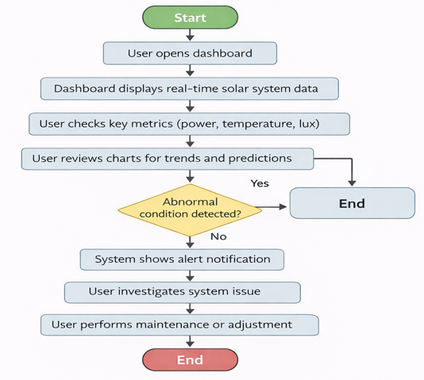

Step 3: Ideate – Dashboard Concept and Information Architecture

3.1 Dashboard Concept
The proposed dashboard visualizes real-time solar panel performance and predicted energy generation to support monitoring and decision-making. The system integrates IoT sensor data and machine learning predictions to provide actionable insights such as overheating alerts and power fluctuation trends.
The dashboard focuses on three analytical goals:
- Real-time monitoring
  - Track power generation and environmental conditions.
- Predictive insight
  - Forecast solar power output 15 minutes ahead.
- Operational awareness
  - Detect overheating and system performance issues.

3.2 Information Architecture
The dashboard is organized into logical sections to help users quickly locate relevant insights.
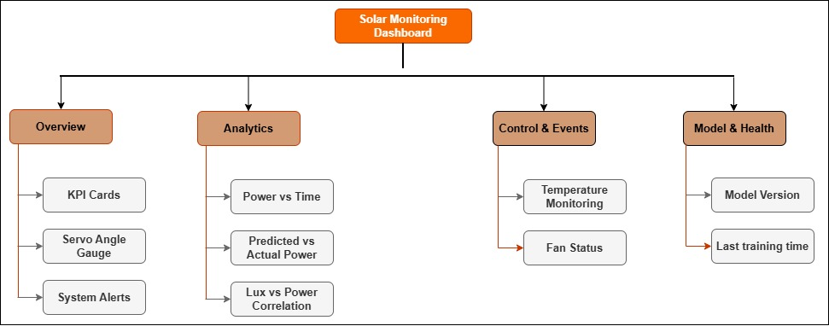

3.3 Navigation Structure

Page | Purpose
Overview | Quick monitoring
Analytics | Detailed trend analysis
System Health | Temperature and cooling
Model Info | ML model status

3.4 Low-Fidelity Wireframes
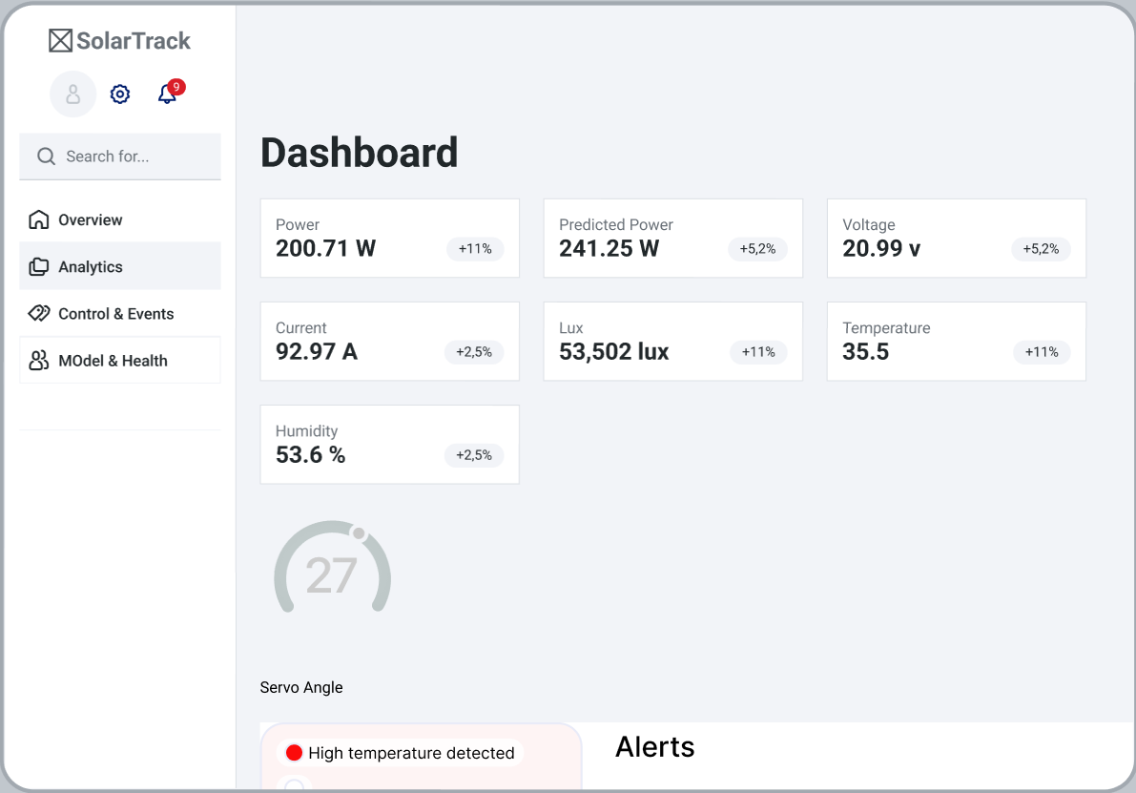
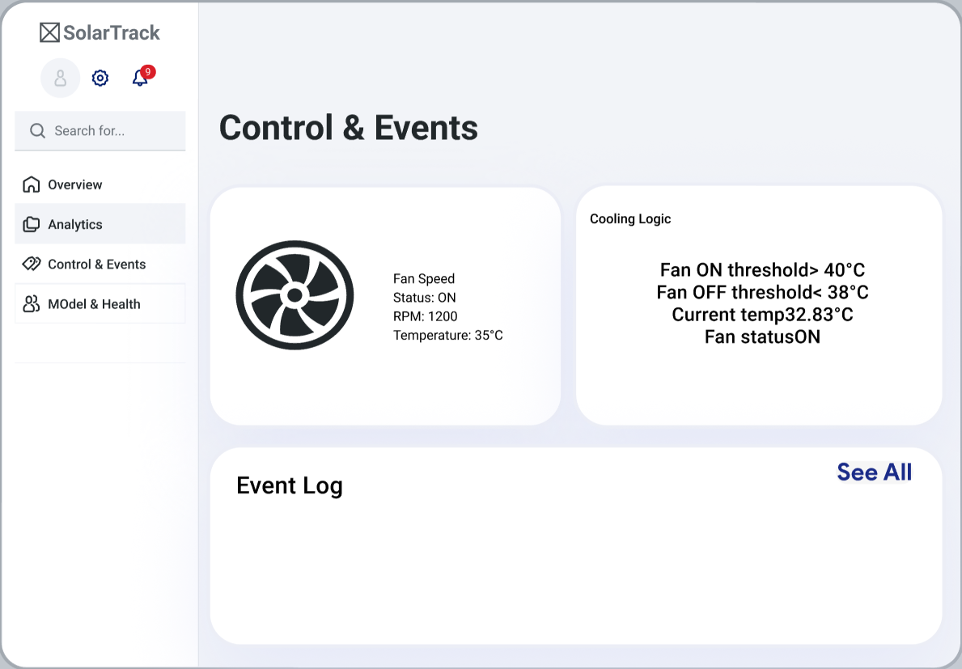
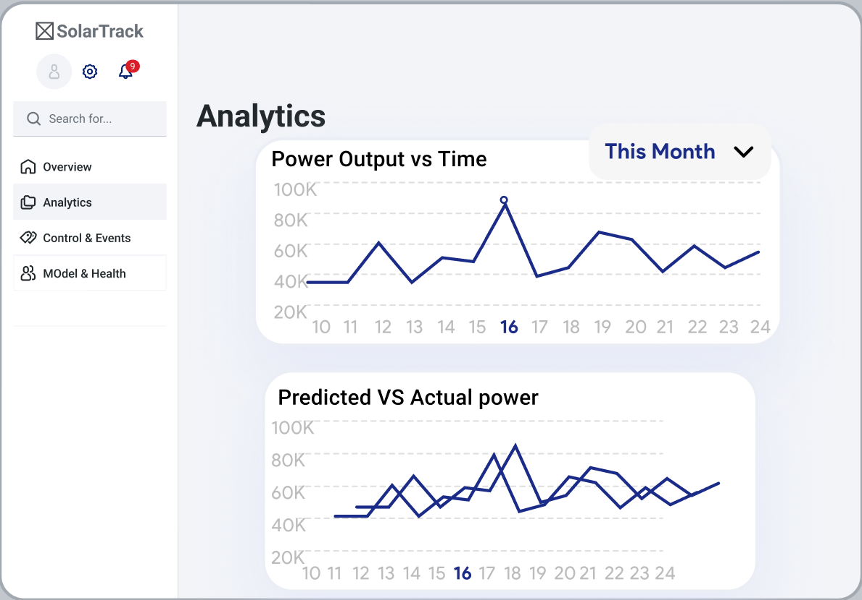

3.5 Visualization Selection

Data Type | Visualization | Reason
Power vs Time | Line Chart | Shows trends over time
Predicted vs Actual | Dual Line Chart | Compare forecast accuracy
Lux vs Power | Scatter Plot | Identify correlation
Temperature | Gauge / Indicator | Quick status recognition
Servo Angle | Radial Gauge | Shows directional position
Fan Status | Badge Indicator | Simple state representation

Interaction Mechanisms

The dashboard includes several interaction features to improve usability.
Time Filters
Users can select time ranges such as:
- 15 minutes
- 1 hour
- 24 hours
Auto Refresh
Data updates automatically every 5–10 seconds.
Hover Tooltips
Charts display exact values when users hover over data points.
Alert Notifications
Warnings appear when:
- Temperature exceeds threshold
- Solar power drops suddenly
- Sensor data becomes invalid

Step 4: Prototype – High-Fidelity Interactive Design

4.1 High-Fidelity Dashboard Design
The prototype includes the following major components:
Component | Purpose
KPI Cards | Display key metrics such as power, temperature, lux, and predicted power
Servo Angle Gauge | Shows current solar panel orientation
Alerts Panel | Displays system warnings such as overheating
Power vs Time Chart | Shows power generation trends
Predicted vs Actual Chart | Compare forecasted and real power output
Lux vs Power Scatter Plot | Analyze relationship between sunlight and power
Fan Status Indicator | Shows cooling system activity

4.2 Responsive Design
Desktop Layout
- Multiple charts visible simultaneously
- Large visualization area
- Side navigation panel
Tablet Layout
- Charts stacked vertically
- Reduced spacing between components
Mobile Layout
- KPI cards displayed in vertical layout
- Charts simplified for readability

4.3 Mobile View
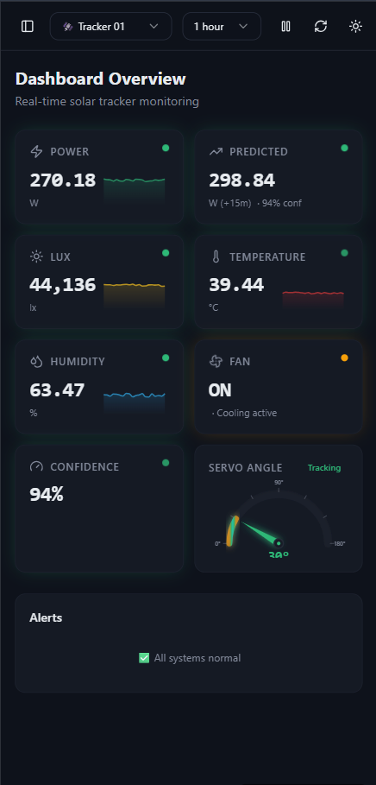

4.4 Desktop View
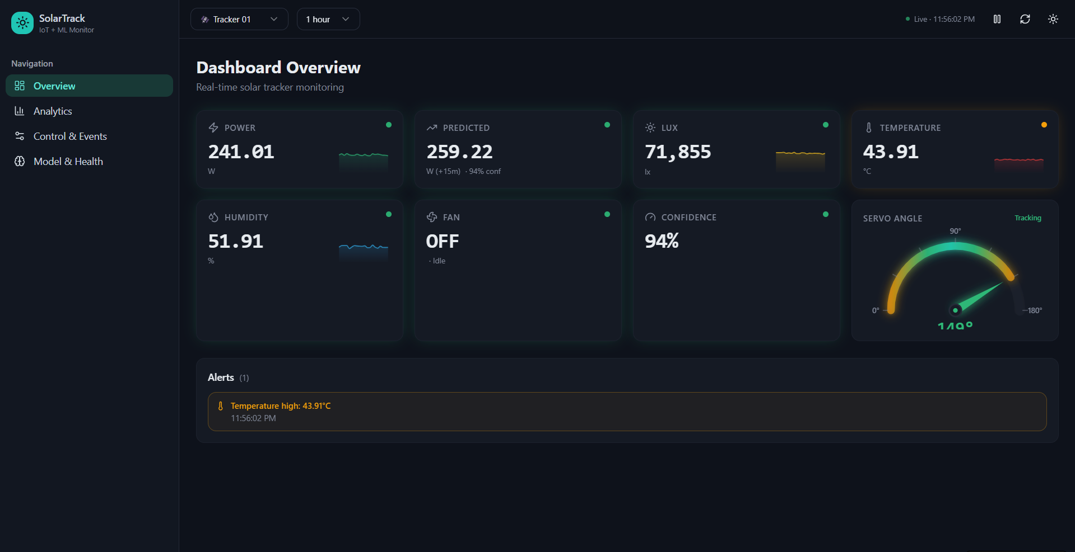

4.4 Interactive Features
Interaction | Description
Time range filter | Users can select time ranges such as 15 minutes, 1 hour, or 24 hours
Auto refresh | Dashboard updates automatically with new data
Hover tooltips | Display exact values when hovering over charts
Alert notifications | Warnings appear when system thresholds are exceeded
Prediction comparison | Users can view predicted vs actual solar power

4.4 Interactive Features

Visual Hierarchy
Important information such as current power and predicted power is placed at the top of the dashboard.
- Color Coding
Color | Meaning
Green | Normal operation
Yellow | Warning
Red | Critical condition

4.5 Prototype Screenshots
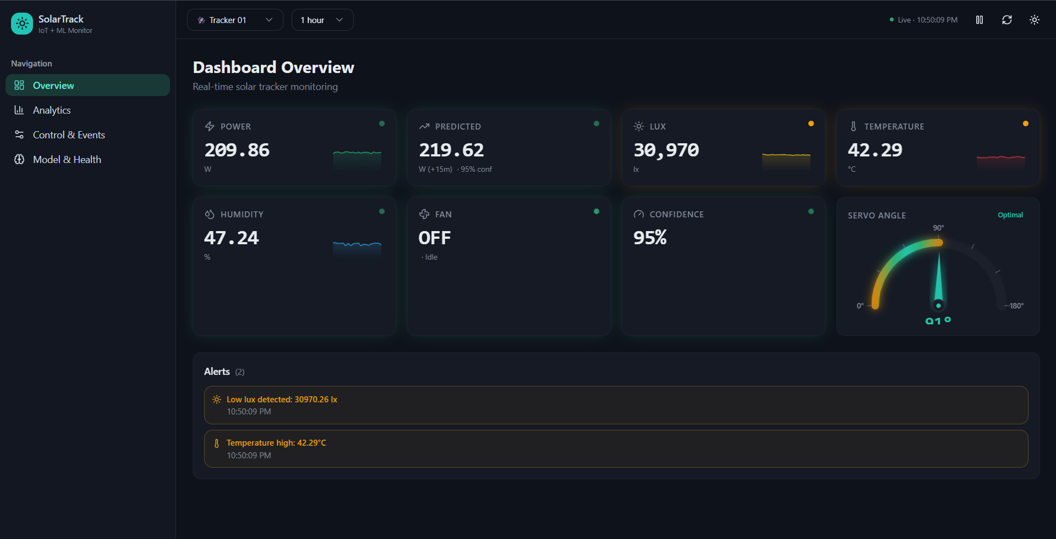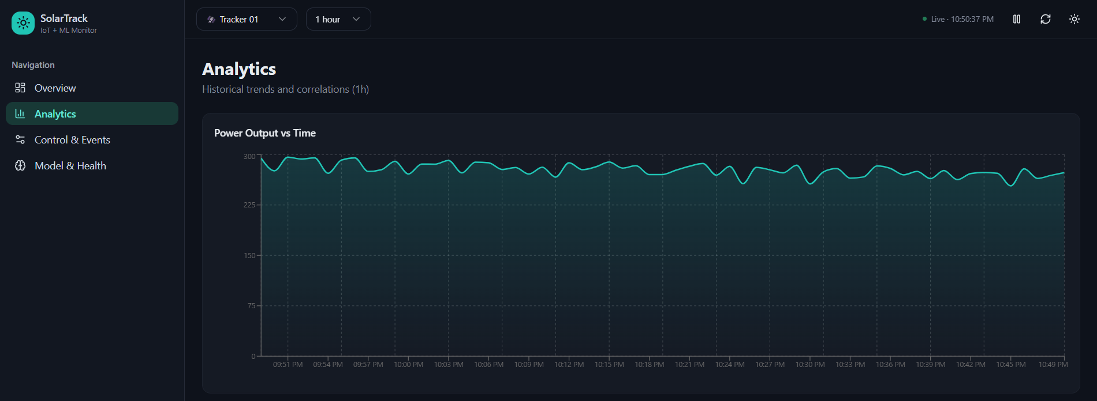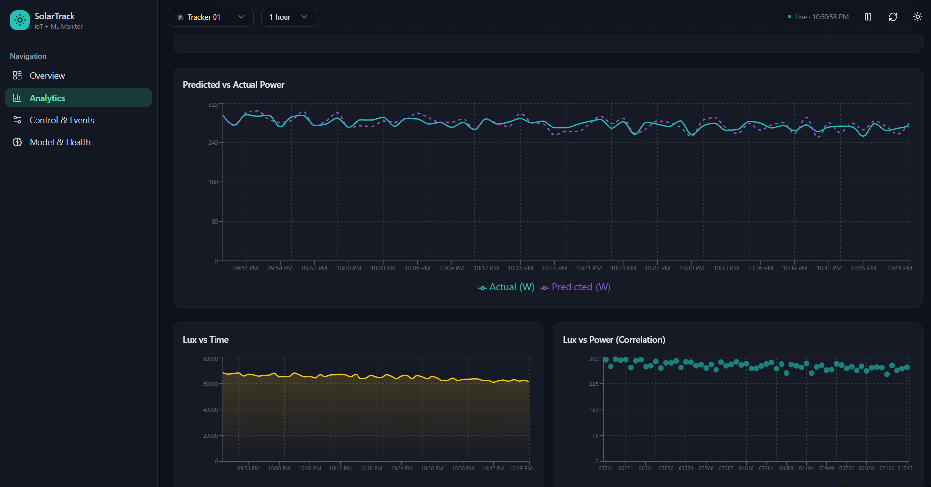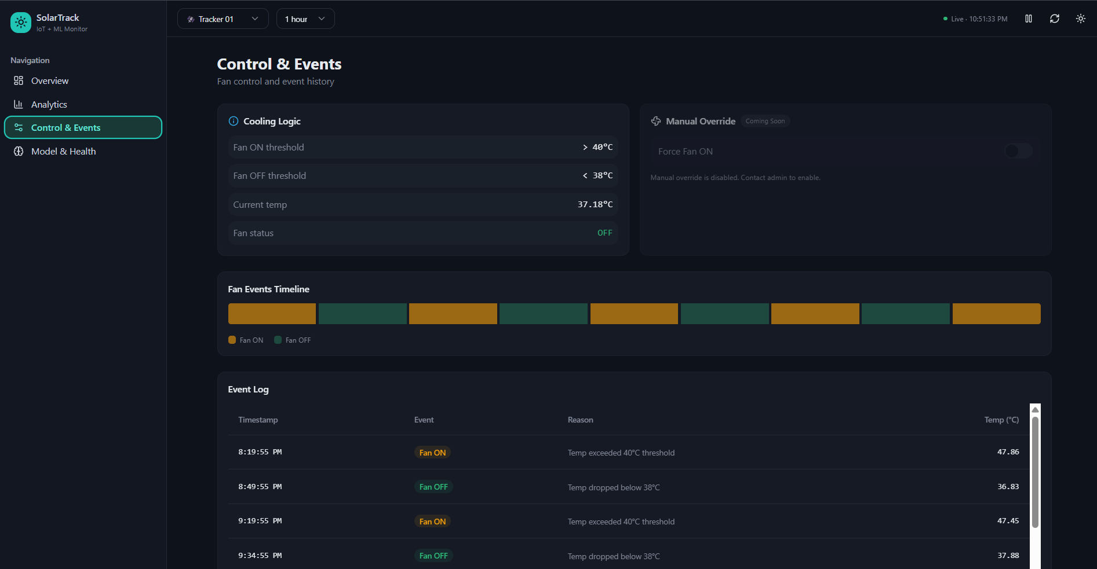

4.6 Prototype Link
https://solartrack-iot.lovable.app/

Step 5: Test – Usability Evaluation

The usability evaluation was conducted to assess the effectiveness of the proposed solar monitoring dashboard in supporting user tasks such as real-time monitoring, anomaly detection, and trend analysis. The evaluation focused on measuring usability factors including task completion efficiency, ease of interpretation of visualizations, and overall user satisfaction. The goal was to determine whether the dashboard design supports the needs of different stakeholders.

5.1 Stakeholders Involved in Usability Testing

The usability evaluation involved four stakeholders, each representing one of the primary user roles identified during the user research phase. These stakeholders reflect the main users who interact with the solar monitoring dashboard in different operational and analytical contexts.
Each stakeholder interacted with the high-fidelity dashboard prototype and completed several monitoring and analysis tasks based on their responsibilities.
Stakeholder | Role | Background
Stakeholder 1 | Solar System Operator | Responsible for monitoring real-time solar system performance and ensuring the system operates efficiently.
Stakeholder 2 | Energy Manager | Plans and manages energy consumption based on solar power generation trends and predictions.
Stakeholder 3 | Maintenance Technician | Responsible for detecting hardware faults, monitoring temperature levels, and performing system maintenance.
Stakeholder 4 | Academic Evaluator | Analyzes system performance data and evaluates solar tracking efficiency and predictive model accuracy.

5.2 Task-Based Usability Testing
Participants were asked to complete tasks that simulate real-world monitoring activities using the dashboard prototype.

Task | Description | Related User Story
Task 1 | Identify the current solar power generation value | Solar System Operator
Task 2 | Check whether the system temperature is within safe limits | Maintenance Technician
Task 3 | Compare predicted solar power output with actual power generation | Energy Manager
Task 4 | Identify any system alerts or abnormal conditions | Maintenance Technician
Task 5 | Analyze the relationship between sunlight intensity and power generation using the charts. | Academic Evaluator

5.3 Usability Metrics
Several usability metrics were used to evaluate the effectiveness of the dashboard.
- Task Completion Rate
Task | Success Rate
View real-time power | 100%
Check temperature status | 100%
Compare predicted vs actual power | 75%
Detect system alerts | 100%
Analyze lux vs power relationship | 75%

Most participants were able to successfully complete the monitoring tasks, indicating that the dashboard provides clear and accessible system information.
- Time on Task
Task | Average Completion Time
Real-time monitoring | 8 seconds
Temperature check | 10 seconds
Prediction comparison | 15 seconds
Alert identification | 7 seconds
Data analysis | 20 seconds

Tasks related to data analysis required slightly more time due to the interpretation of analytical charts.
- User Satisfaction
Evaluation Criteria | Average Rating
Dashboard layout clarity | 4.5
Ease of understanding visualizations | 4.3
Effectiveness of alerts | 4.6
Ease of identifying system status | 4.7
Overall usability | 4.5

Overall, users reported high satisfaction with the dashboard interface.

5.4 Heuristic Evaluation

The dashboard was also evaluated using selected principles from Nielsen’s Usability Heuristics.
Heuristic Principle | Observation
Visibility of system status | KPI cards display real-time system metrics clearly
Match between system and real world | Data values use familiar units such as watts, lux, and temperature
Consistency and standards | Visualization styles are consistent across charts
Recognition rather than recall | Gauges and indicators help users quickly identify system status
Error prevention | Alerts notify users when temperature or power values exceed thresholds

The evaluation indicates that the dashboard design follows key usability principles.

5.5 Key Findings

The usability evaluation revealed several important findings:
- Users were able to quickly understand real-time solar system status using KPI cards and gauges.
- The Power vs Timeline chart was considered the most useful visualization for monitoring trends.
- Alert notifications effectively helped users identify abnormal system conditions.
- The Predicted vs Actual power chart supported energy planning and performance evaluation.
- Some users required additional time to interpret the Lux vs Power scatter plot.
Overall, the dashboard successfully supported the main monitoring and analysis tasks required by users.

5.6 Usability Issues Identified

Although the overall usability was positive, several minor issues were identified during testing.
Issue | Description
Scatter plot interpretation | Some users needed clearer labels to understand correlation between lux and power
Prediction chart labeling | A few participants suggested clearer legend descriptions
Alert visibility | Alerts could be visually highlighted more strongly

5.7 Recommendations for Improvement

Based on the usability evaluation results, the following improvements are recommended:
- Add clearer chart labels and legends for analytical visualizations.
- Enhance alert visibility using stronger color indicators or icons.
- Provide short tooltips explaining analytical charts.
- Improve visual emphasis on prediction results for easier comparison.
These improvements will further enhance the usability and effectiveness of the solar monitoring dashboard.

Step 6: Iterate – Design Refinement

After completing the usability evaluation, several insights and usability issues were identified. The purpose of the iteration stage is to refine the dashboard design in order to improve usability, clarity of visualizations, and overall user experience. Through this process, the dashboard interface was refined to ensure that users can more easily interpret solar system data, detect anomalies, and analyze system performance.

6.1 Identified Usability Issues

The usability evaluation highlighted several areas where the dashboard design could be improved.

Issue | Description
Scatter plot interpretation | Some stakeholders found the Lux vs Power scatter plot difficult to interpret initially.
Prediction chart labeling | The predicted vs actual power chart required clearer labels to distinguish forecast values.
Alert visibility | System alerts could be more visually prominent for faster detection.
Chart readability | Some charts required clearer legends and tooltips to support quick interpretation.

6.2 Design Improvements

Several improvements were implemented to enhance the usability and clarity of the dashboard.
- Improved Chart Labels and Legends
Chart titles, axis labels, and legends were enhanced to clearly describe the data being displayed. This helps stakeholders quickly understand the meaning of each visualization without additional explanation.
- Enhanced Alert Visibility
Alert notifications were redesigned using stronger visual indicators such as warning icons and color highlighting. This improvement allows maintenance technicians and operators to quickly detect abnormal system conditions such as overheating or sudden power drops.
- Improved Prediction Chart Clarity
The predicted vs actual power visualization was refined by adding clear legend labels and color differentiation between forecasted and real values. This helps energy managers and evaluators easily compare prediction accuracy.
- Tooltip Enhancements
Additional tooltips were added to charts so that stakeholders can view precise data values when hovering over data points. This improves data interpretation without cluttering the interface.
- Improved Layout Consistency
The dashboard layout was refined to ensure consistent spacing, alignment, and grouping of visual elements. This improvement supports easier navigation and improves visual hierarchy.

6.3 Before–After Design Comparison

Feature | Before Iteration | After Iteration
Scatter plot | Basic chart without explanation | Added clearer axis labels and tooltips
Prediction chart | Limited distinction between lines | Clear legend and improved labeling
Alert system | Simple alert text | Highlighted alerts with icons and visual indicators
Chart interaction | Basic hover interaction | Enhanced tooltips with precise values
Layout | Slightly crowded chart placement | Improved spacing and visual grouping

6.4 Design Iteration Summary

The iteration stage significantly improved the usability of the solar monitoring dashboard. By incorporating stakeholder feedback and usability testing insights, the refined dashboard provides clearer visualizations, more effective alert mechanisms, and improved data interpretation capabilities.
These design improvements ensure that the dashboard better supports the needs of different stakeholders, including solar system operators, energy managers, maintenance technicians, and academic evaluators.
The refined design enhances the overall user experience and strengthens the dashboard’s ability to support real-time monitoring, predictive analysis, and operational decision-making.

Step 7: Design Handoff Report

7.1 Final Dashboard Structure

The final solar monitoring dashboard is designed to provide an integrated interface for monitoring system performance, analyzing historical trends, and evaluating predictive insights. The dashboard layout follows a structured hierarchy that prioritizes critical system indicators and monitoring information.

The interface is organized into the following main sections:
- Header Section – Displays the dashboard title and system status information.
- KPI Summary Section – Shows key system metrics such as power output, temperature, sunlight intensity (lux), and predicted power values.
- Real-Time Monitoring Section – Displays charts that visualize solar system performance over time.
- Prediction Analysis Section – Provides visual comparison between predicted solar power output and actual power generation.
- System Diagnostics and Alerts Panel – Displays system warnings such as overheating conditions or abnormal power fluctuations.
- Device Status Indicators – Shows the operational state of system components such as cooling fans and solar tracking orientation.
This layout allows stakeholders to quickly assess system status while providing access to deeper analytical insights.

7.2 Screen Specifications

The dashboard includes several UI components designed to present system data clearly and efficiently.
Component | Description | Data Source
KPI Cards | Display key system metrics including current power generation, panel temperature, sunlight intensity (lux), and predicted power output | IoT sensor data
Power vs Timeline Chart | Shows solar power generation trends over time | Power sensor
Predicted vs Actual Power Chart | Compare forecasted solar power generation with real system output | Prediction model
Lux vs Power Scatter Plot | Visualizes the relationship between sunlight intensity and power generation | Light sensor
Servo Angle Gauge | Displays the orientation angle of the solar panel tracking system | Servo motor
Temperature Indicator | Shows panel temperature status and highlights overheating conditions | Temperature sensor
Alerts Panel | Displays warnings when abnormal conditions are detected | System monitoring logic
Fan Status Indicator | Shows the operational state of the cooling system | Device control system

These components provide both real-time monitoring and analytical insights for system evaluation.

Interaction Behaviors

The dashboard includes several interactive features designed to improve usability and data exploration.
Time Range Filters
Users can adjust the time range displayed in charts to analyze different monitoring periods.
Available time filters include:
- Last 15 minutes
- Last 1 hour
- Last 24 hours

Auto Refresh
The dashboard automatically updates system data every 5–10 seconds to ensure that users always see the latest sensor readings and system status.
Hover Tooltips
Interactive tooltips appear when users hover over chart elements. These tooltips display precise data values such as timestamp, power output, lux value, or predicted energy generation.
Alert Notifications
The system generates alerts when abnormal conditions occur. Alerts are triggered under the following conditions:
- Panel temperature exceeds safe limits
- Solar power output drops unexpectedly
- Sensor values become invalid or unavailable
These alerts help stakeholders quickly detect system issues and respond appropriately.

Visualization Guidelines

Data Type | Visualization | Purpose
Solar power generation | Line Chart | Shows power generation trends over time
Predicted vs Actual Power | Dual Line Chart | Enables comparison between forecasted and actual system performance
Sunlight intensity vs Power | Scatter Plot | Identifies correlation between sunlight intensity and power output
Panel Temperature | Gauge / Indicator | Allows quick identification of overheating conditions
Servo Panel Angle | Radial Gauge | Displays solar panel orientation relative to sunlight
Fan Status | Badge Indicator | Shows the operational state of the cooling system

Responsive Design Guidelines

The dashboard is designed to adapt to different screen sizes to support usability across multiple devices.
- Desktop Layout: The desktop layout provides a full analytical view of the system. Multiple charts and KPI indicators are visible simultaneously, allowing users to monitor system performance efficiently.
- Tablet Layout: On tablet devices, the dashboard layout adjusts by stacking charts vertically and reducing spacing between components. This ensures readability while maintaining the availability of analytical insights.
- Mobile Layout: For mobile devices, the dashboard prioritizes key information. KPI cards are displayed in a vertical arrangement, and charts are simplified to maintain clarity on smaller screens.
This responsive design approach ensures that the dashboard remains usable across different platforms.

Accessibility Considerations

Several design considerations were implemented to improve accessibility and usability for all users.
- Clear chart titles and labels are used to improve data interpretation.
- Tooltips provide detailed values without cluttering the interface.
- Alerts use both icons and color indicators to improve visibility.
- Font sizes are selected to ensure readability across devices.
- Consistent visual hierarchy guides users to the most important system information.
These accessibility improvements support efficient monitoring and analysis for different stakeholder groups.

7.7 Implementation Considerations
The prototype of the solar monitoring dashboard was designed using Figma, which allows interactive visualization of the dashboard layout and functionality.
For practical implementation, the dashboard could be developed using a web-based architecture that integrates IoT sensor data and predictive analytics.
Possible implementation technologies include:
- Frontend: React
- Visualization libraries: Chart.js or D3.js
- Data integration: APIs connected to IoT sensor devices
- Prediction model: Machine learning model for short-term solar power forecasting
These technologies would enable the dashboard to display real-time sensor data, historical trends, and predictive insights in an interactive environment.

AI Tools Usage
AI Tool | Purpose | Stage Used
ChatGPT | Assisted in structuring sections of the report, refining technical explanations, generating example system architecture descriptions, and supporting troubleshooting during IoT integration tasks. | Ideation, implementation support, and report documentation
GitHub Copilot | Provided coding assistance by suggesting code snippets, improving code structure, and supporting debugging during the development of IoT device scripts and backend services. | Implementation and debugging phases
Lovable | Utilized to design and develop the high-fidelity interactive dashboard prototype for visualizing solar tracker data such as temperature, humidity, power generation, and servo orientation. | Dashboard prototyping and frontend interface development

